INDECOM investigators to undergo training
Friday, November 23, 2012

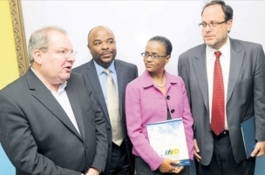

THIRTY-FIVE investigators from the Independent Commission of Investigations (INDECOM) are to undergo training to improve their investigative skills through a programme at the Management Institute for National Development (MIND).

The Professional and Investigative Skills Training for the Independent Commission of Investigations, which was developed by MIND in collaboration with the United Kingdom-based University of Portsmouth Institute of Criminal Justice Studies (ICJS), is set to run over the next 27 days.

Justice Minister Senator Mark Golding, who officially launched the programme at MIND on Monday, said the programme provided a ray of hope for the justice system.

"It (the programme will enhance the competence and professionalism with which INDECOM's investigators perform their duties in assuring the protection of the human rights of our citizens and fair outcomes for the security forces," said Senator Golding.

"It will assist INDECOM to meet its self-imposed 60-day target for completing investigations, and raise the bar for the timely execution of important tasks in the sector," Senator Golding said.

Monday, the justice minister said despite improvements this year, the abuse of human rights by state agents, especially through the use of deadly force, continues to be a major challenge to the rule of law.

He called on the leadership and rank and file members of the island's security forces to embrace INDECOM.

"INDECOM must be embraced by the leadership and rank and file of the security force, as it will only help to make them (police) more effective," said Golding.

The minister also highlighted reports from Amnesty International that every year, around 12 per cent of killings are attributed to the police but that convictions of police officers for unlawful killings are 'rare'.

The minister said the Government was grateful to the UK's (Department For International Development) for their support of £1.5 million over the next three years.

"I am aware that approximately J$50 million of that amount has made this training and certification possible.

Part of the funds has also been allocated to INDECOM to acquire a comparison microscope, set up its own laboratory as well as to engage a ballistic expert to reduce the backlog of ballistic investigation, the minister said.

